**WEB PROGRAMMING Lab Manual PCS693**

**Exp No: 1 : Basic Html Tags**

**Aim:** To create a simple html file to demonstrate the use of different tags.

**Problem Statement :-**

Create an html page named as “**:** Basic_Html_Tags.html” Add the following tags detail.

1. Set the title of the page as “Basic Html Tags”
2. Within the body perform the following
3. Moving text = “Basic HTML Tags”
4. Different heading tags ( h1 to h6)
5. Paragraph
6. Horizontal line
7. Line Break
8. Block Quote
9. Pre tag
10. Different Logical Style ( <b>, <u>, <sub>, <sup>. )
11. Different Physical style ( <code>, <del>, <kbd> )
12. Listing tags ( 2 types with, & each type provide different “type” attribute)

**HTML Document Structure:**

<html>

<head>

<title></title>

</head>

<body></body>

</html>

**Formatting and Fonts:**

<br> - break tag – makes output on the next line.

<p> - paragraph tag – places a blank line before the line it is on. <hr> - horizontal tag – creates a line or horizontal rule.

<pre> - preformatted tag - enables one to embed text that is already formatted . <i> - Italic font

<b> - Bold font

<em> - Emphasis

<sup> - Superscript

<sub> - Subscript

**Font Size:**

<font> tag and <h....> tag

<h1> - 24 pt <font size=7> - 36 pt

<h2> - 18 pt <font size=6> - 24 pt

<h3> - 12 pt <font size=5> - 18 pt

<h4> - 12 pt bold <font size=4> - 12 pt bold <h5> - 10 pt <font size=3> - 12 pt plain <h6> - 7 pt <font size=2> - 9 pt

**Text alignment:**

<p align=”center”> - align the text in center.

<h1 align=”left”> - align the text in left.

<h2 align=”right”> - align the text in right.

The “align” tag can be used with <p> tag and <h.> tag **Color:**

1. Set background color and text color - <body bgcolor=”blue” text=”red”> <body bgcolor=”#800000”>
2. Set text color only - <font color=”brown”>

**Code:**

<!DOCTYPE html>

<html>

<head>

<title>Exp-1</title>

</head>

<body>

<h4 align="center">Basic HTML Tags</h6>

<h2 align="center"><font color="red">Heading Tage => font size-18pt, colour-RED</font></h2>

<h1 align="center">Heading H1 - 24 pt</font></h1>

<h2 align="right">Heading H2 - 18pt</h2>

<h3>Heading H3 - 12 pt bold</h3>

<h4>Heading H4 - 12 pt</h4>

<h5>Heading H5 - 10 pt</h5>

<h6>Heading H6 - 7 pt</h6>

<font size="7">font size-36 pt,</font>

<font size="6">font size-24 pt,</font>

<font size="5">font size-18 pt,</font>

<font size="4">font size-12 pt bold,</font>

<font size="3">font size-12 pt plain,</font>

<font size="2">font size-9 pt,</font>

<h4 align="center"><font color="lime">Heading Tage => font size-18pt, colour-Lime</font></h4>

<p>Lorem ipsum dolor sit ametm mattis ullamcosed.

At volutpat diam ut venenatis tellus in. A scelerisque purus semper eget. Magna

fringilla urna porttitor rhoncus dolor purus non enim. Facilisis leo vel fringilla

est ullamcorper eget nulla facilisi. Porta nibh venenatis cras sed felis. Venenatis

tellus in metus vulputate eu scelerisque felis imperdiet. Diam volutpat commodo sed

egestas egestas fringillatellus in hac habitasse platea dictumst.p>

</body>

</html>

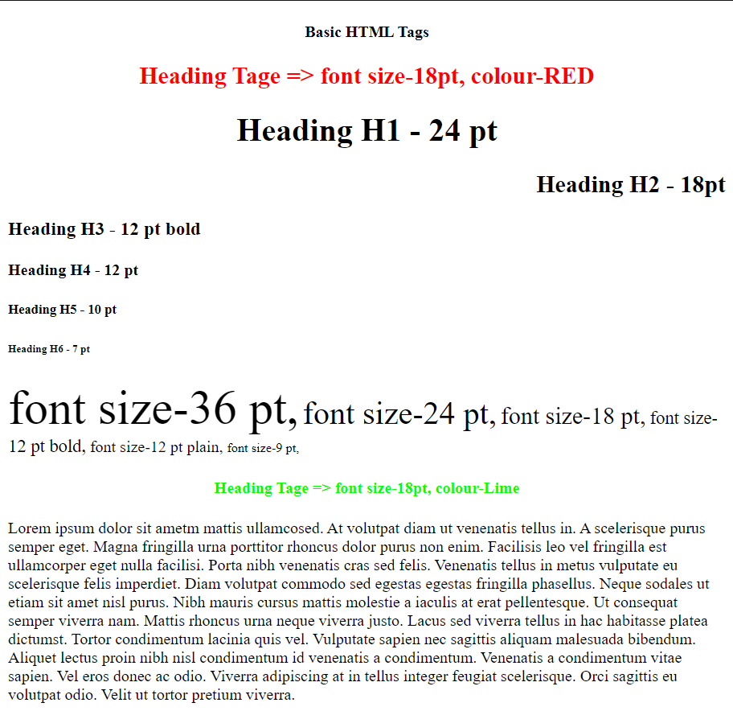**Output:**

**Exp No: 2 : Html Tags (List, Table)**

**Aim**: To create a simple html file to demonstrate the use of different tags.

**Code**:

**a)** **List**

<!DOCTYPE html>

<html>

    <head><title>Exp-2a</title>

    </head>

    <body>

        <h2>Here is a nested ordered list:</h2>

        <ol type="I">

            <li>Module 1</li>

            <li>Module 2</li>

            <ol type="i">

                <li>Module 2.1</li>

                <li>Module 2.1</li>

            </ol>

            <li>Module 3</li>

        </ol>

        <h3>Disc bullets list:</h3>

        <ul type="disc">

            <li>Keyboard</li>

            <li>Mouse</li>

            <li>Monitor</li>

        </ul>

        <h3>Circle bullets list:</h3>

        <ul type="Circle">

            <li>CRT</li>

            <li>LCD</li>

            <li>LED</li>

        </ul>

        <h3>Square bullets list:</h3>

        <ul type="Square">

            <li>Windows</li>

            <li>Linux</li>

            <li>Android</li>

        </ul>

        <h3>A definition list:</h3>

        <dl>

            <dt>Coffee</dt>

            <dd>Black Coffee OR Milk Coffee</dd>

            <dt>Milk</dt>

            <dd>Hot White milk OR Cold Chocolate Milk</dd>

        </dl>

    </body>

</html>

**b) Table**

<!DOCTYPE html>

<html>

<head>

<title>Exp-2b</title>

<style>

td{

text-align: center;

}

.periods{

background-color: pink;

}

.periods-title{

background-color: rgb(208, 208, 20);

}

.days-title{

background-color: rgb(181, 6, 6);

}

.days{

background-color: rgb(152, 150, 150);

}

.cyan{

background-color: cyan;

}

.dark-green{

background-color: green;

}

.yellow{

background-color: yellow;

}

.dark-yellow{

background-color: rgb(104, 122, 24);

}

.red{

background-color: red;

}

</style>

</head>

<body>

<h1 align=center>Government Polytechnic College<br>DEPARTMENT OF Computer Engineering<br>EFFECTIVE FROM: 01-07-2016</h1>

<table border="1" align="center" cellpadding="10px">

<thead>

<tr class="periods">

<th class="periods-title" colspan="1">Periods</th>

<th rowspan="2">1</th>

<th rowspan="2">2</th>

<th rowspan="2">3</th>

<th rowspan="2">4</th>

<th rowspan="2">5</th>

<th rowspan="2">6</th>

<th rowspan="2">7</th>

</tr>

<tr class="days-title">

<th colspan="1">Days</th>

</tr>

</thead>

<tbody>

<tr>

<td class="days">Monday</td>

<td>IT0302</td>

<td>IT0306</td>

<td>IT0304</td>

<td>IT0306</td>

<td>IT0302</td>

<td colspan="2">IT0304</td>

</tr>

<tr>

<td class="days">Tuesday</td>

<td colspan="4" class="cyan">IT0320/IT0322</td>

<td class="dark-yellow">IT0310</td>

<td>IT0304</td>

<td>IT0308</td>

</tr>

<tr>

<td class="days">Wednesday</td>

<td colspan="2" class="yellow">ELECTIVE - I</td>

<td>IT0306</td>

<td>IT0310</td>

<td>IT0304</td>

<td>IT0308</td>

<td>COUN</td>

</tr>

<tr>

<td class="days">Thursday</td>

<td>IT0302</td>

<td>IT0304</td>

<td colspan="2">PD0302</td>

<td colspan="3" class="dark-green">IT0320/IT0322</td>

</tr>

<tr>

<td class="days">Friday</td>

<td>IT0308</td>

<td>IT0306</td>

<td>8IT0308</td>

<td>IT0302</td>

<td colspan="2" class="red">ELECTIVE - I</td>

</tr>

</tbody>

</table>

</body>

</html>

**Output**:

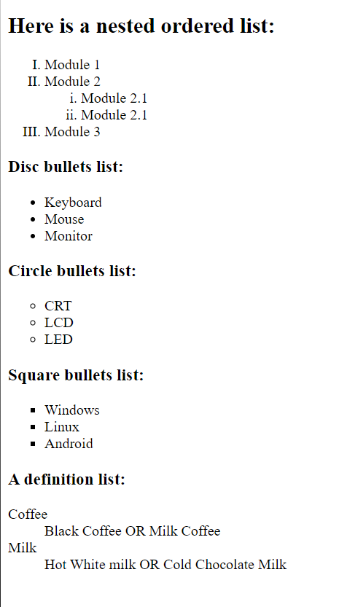

**a)**

**b)**

**Exp No: 3: Html Tags (Form)**

**Aim:** To create a simple html file to demonstrate the use of different tags.

**Code:**

<html>

<head> <title>3</title></head>

<body bgcolor="lightblue" text="red" style="font-size:15pt;font-family:Garamond"

><center>

<h2>ENTRY FORM</h3></center>

<form name=form1 >

<table name=tab cellspacing=20pt>

<tr><td align=left><h2>Enter your Name :</h2> </td><td align=left><input type=text name=t1 size=18>

<tr><td align=left><h2>Enter your Age :</h2> </td><td align=left><input type=text name=t2 maxlength=3 size=3>

<tr><td align=left><h2>Enter your Address :</h2> </td><td align=left><textareaname=ta rows=5 cols=15></textarea>

<tr><td align=left><h2>Sex :</h2> </td><td align=left><input type=radio name=r1 value="female" checked=true>Female<br>

<input type=radio name=r1 value=male>Male</td>

<tr><td align=left><h2>Nationality :</h2> </td><td align=left><select name="country">

<option selected="" value="Default">(Please select a country)</option>

<option value="AF">India</option>

<option value="AL">Canada</option>

<option value="DZ">Australia</option>

<option value="AS">Russia</option>

<option value="AD">USA</option>

</select></td>

<tr><td align=left><h2>Languages Known :</h2> </td><td align=left><center>(can select more than one)</center>

<input type=checkbox name=c1 value=c checked=true> C<br><input type=checkbox name=c2 value=c++> C++<br><input type=checkbox name=c3 value=vb> VB<br><input type=checkbox name=c4 value=java> JAVA<br><input type=checkbox name=c5 value=asp> ASP<br><input type=checkbox name=c6 value=others> OTHERS<br></td><tr><td align=left><h2>Enter your Password :</h2> </td><td align=right><input type=password name=t3 size=18>

</table><center><input type=reset value=" Reset " ><input type=submit value=" Submit " >

</form>

</body></html>

**Output:**

**Exp No: 4: Frames**

**Aim**: To create an html page with different types of frames such as floating frame, navigation frame & mixed frame.

**Problem Statement:**

1. Create an html page named as “frames.html”. Divide the page into two columns of 20%, 80% size. In 20% size call the hyperlinks for “navigationframes.html”, “floatingframes.html”, “mixedframe.html”, “noframe” and make the page to be get displayed on the other column when these links are clicked.

2. Create an html page named as “navigationframe.html”. Divide the page into two columns of 40%, 60% size. In 40% size call the hyperlink file created in above exercise and make the page to be get displayed on the other column when the link is clicked.

3. Create an html page named as “floatingframes.html”. In this file include a paragraph to explain floating frame, and in floating frame include the any html file created in the above exercise as inline.

4. Create an html page named as “mixedframe.html” . Divide the page into two columns of 25% & 75% size. In 25% display an image and divide the 75% into two rows. (50% & 50%). In the first 50% display the video file created in previous exercise and other 50% the timetable created in previous exercise.

**Code:**

1. **Frames.html**

<!DOCTYPE html>

<html lang="en">

<head>

    <title>Document</title>

</head>

<body>

    <a href="4b.html" target="a">navigation frame</a><hr>

    <a href="4a.html" target="a">floating frame</a><hr>

    <a href="4c.html" target="a">mixed frame</a><hr>

</body>

</html>

1. **navigationframe.html**

<!DOCTYPE html>

<html lang="en">

<head>

    <title>Navigation Frame</title>

</head>

<frameset cols="40%,60%",border="10",frameborder="1">

    <frame name="navigation" src="1.html">

        <frame name="a">

</frameset>

<body>

</body>

</html>

1. **Floatingframe.html**

<!DOCTYPE html>

<html lang="en">

<head>

    <title>Floating Frame</title>

</head>

<frameset cols="20%,40%,20%",border="10",frameborder="1">

  <frame name="floatingframe" src="14.html">

         <frame name="file" src="9b.html">

         <frame name="a">

</frameset>

<body>

</body>

</html>

1. **Mixedframe.html**

<!DOCTYPE html>

<html>

<head><title>Mixed Frame</title></head>

<frameset cols="25%,75%">

    <frame src="3.html">

    <frameset rows="50%,50%">

        <frame src="2a.html">

        <frame src="2b.html">

    </frameset>

</frameset>

</html>

**Output:**

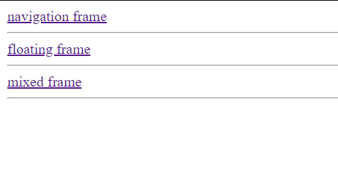**a)**

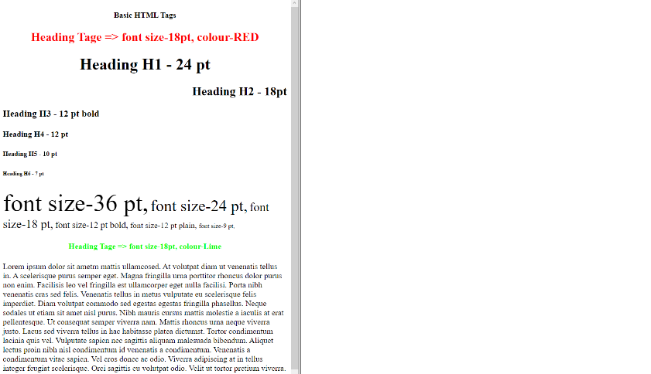**b)**

**c)**

**d)**

**Exp No: 5 : Map**

**Aim:** To create an html page with different types of image map such as circle, rect , poly & mixed map.

**Problem Statement:**

1. To display an image on the website and construct a map for all circle buttons, develop the "dialler.html" HTML page. When you click on a circle, a message with a button number, such as "you push button 1," will appear.

**Code:**

<!DOCTYPE html>

<html lang="en">

<head>

<title>5</title>

</head>

<body>

<div align="center">

<img src="picture.JPG" style="margin-top: 200px; "alt=" KeyPad Picture" height="600px" usemap="#mymap">

<map name="mymap">

<area shape="circle" coords="74,85,50" onclick="alert('KeyPressed is 1');">

<area shape="circle" coords="213,85,50" onclick="alert('KeyPressed is 2')">

<area shape="circle" coords="356,85,50" onclick="alert('KeyPressed is 3')">

<area shape="circle" coords="74,235,50" onclick="alert('KeyPressed is 4')">

<area shape="circle" coords="213,235,50" onclick="alert('KeyPressed is 5')">

<area shape="circle" coords="356,235,50" onclick="alert('KeyPressed is 6')">

<area shape="circle" coords="74,376,50" onclick="alert('KeyPressed is 7')">

<area shape="circle" coords="213,376,50" onclick="alert('KeyPressed is 8')">

<area shape="circle" coords="356,376,50" onclick="alert('KeyPressed is 9')">

<area shape="circle" coords="74,524,50" onclick="alert('KeyPressed is *')">

<area shape="circle" coords="213,524,50" onclick="alert('KeyPressed is 0')">

<area shape="circle" coords="356,524,50" onclick="alert('KeyPressed is #')">

</map>

</div>

</body>

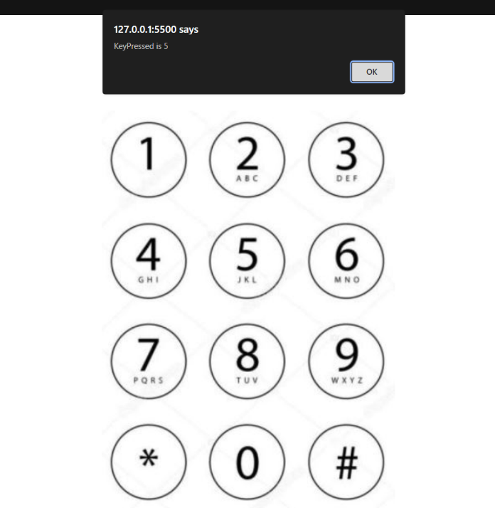

**Output:**

**Exp No: 6 : : Inline, Internal and External Style sheets**

**Aim:** To create an html file by applying the different styles using inline, external & internal style sheets.

**Problem Statement :-**

1. Create a external style sheet named as “external_css.css” and provide some styles for h2, hr, p & a tags.
2. Create an html file named as “4Style_sheet.html”
   1. Include the external style sheet with necessary tag.
   2. Include the internal style sheet for body tags & also use class name, so that the style can be applied for all tags.
   3. Include a <p> tags with inline style sheet.

**Theory:**

Basic syntax:

selector {property:value; property:value; }

selector => identifier of the element e.g.

body {background : yellow; color : yellow}

p {font-family: “Times New Roman”; font-size: 14px} h1,h3 {color : red}

**CSS Selectors**

|  |  |  |
| --- | --- | --- |
| **Selector** | **Example** | **Example description** |
| [.*class*](https://www.w3schools.com/cssref/sel_class.asp) | .intro | Selects all elements with class="intro" |
| [#*id*](https://www.w3schools.com/cssref/sel_id.asp) | #firstname | Selects the element with id="firstname" |
| [*](https://www.w3schools.com/cssref/sel_all.asp) | * | Selects all elements |
| [*element*](https://www.w3schools.com/cssref/sel_element.asp) | p | Selects all <p> elements |
| [*element,element*](https://www.w3schools.com/cssref/sel_element_comma.asp) | div, p | Selects all <div> elements and all <p> elements |
| [*element element*](https://www.w3schools.com/cssref/sel_element_element.asp) | div p | Selects all <p> elements inside <div> elements |
| [*element*>*element*](https://www.w3schools.com/cssref/sel_element_gt.asp) | div > p | Selects all <p> elements where the parent is a <div> element |
| [*element*+*element*](https://www.w3schools.com/cssref/sel_element_pluss.asp) | div + p | Selects all <p> elements that are placed immediately after  <div> elements |
| [*element1*~*element2*](https://www.w3schools.com/cssref/sel_gen_sibling.asp) | p ~ ul | Selects every <ul> element that are preceded by a <p> element |
| [[*attribute*]](https://www.w3schools.com/cssref/sel_attribute.asp) | [target] | Selects all elements with a target attribute |
| [[*attribute*=*value*]](https://www.w3schools.com/cssref/sel_attribute_value.asp) | [target=_blank] | Selects all elements with target="_blank" |
| [[*attribute*~=*value*]](https://www.w3schools.com/cssref/sel_attribute_value_contains.asp) | [title~=flower] | Selects all elements with a title attribute containing the word "flower" |
| [[*attribute*|=*value*]](https://www.w3schools.com/cssref/sel_attribute_value_lang.asp) | [lang|=en] | Selects all elements with a lang attribute value starting with "en" |

**Code:**

1. **Inline CSS**

<!DOCTYPE html>

<html>

<head>

<title>Exp-6a</title>

</head>

<body style="margin: 10px 40px;"">

<h1 style="color:darkgreen; text-align: center; background-color: yellow; border: 5px solid red; padding: 15px;">This is My Stylish Website</h1>

<div style="color:red; display: flex; justify-content: space-around;">

<p>Home</p>

<p>Backgrounds</p>

<p>Lists</p>

<p>Id vs.class</p>

</div>

<h3 style="color:purple; background-color: pink; border-style: dotted;">This website is about me!</h3>

<p style="color:red; font-weight: bold;">My Top Three Favourite Things To Do!</p>

<ol style="color:red; border-style: dashed; background: lightgreen; border-color: darkblue;">

<li><span style="font-weight: bold; font-size: 20px;">T</span>ravel</li>

<li><span style="font-weight: bold; font-size: 20px;">E</span>at ice Cream</li>

<li><span style="font-weight: bold; font-size: 20px;">R</span>ead a boo</li>

</ol>

</body>

</html>

1. **Internal CSS**

<!DOCTYPE html>

<html>

<head>

<title>Exp-6b</title>

<style>

.all{

width: 45%;

margin: auto;

display: flex;

flex-direction: column;

gap: 7px;

}

div{

padding-left: 2px;

}

.header, .footer, .menu, .navbar{

background-color: rgb(212, 164, 41);

border: 3px solid black;

}

.middle{

display: flex;

gap: 7px;

}

.main{

flex: 6;

display: flex;

flex-direction: column;

background-color: grey;

justify-content: space-around;

border: 3px solid black;

}

.navbar{

margin: 5px 5px;

display: flex;

}

button, .box{

margin: 5px 5px;

background-color: cyan;

border: 3px solid black;}

button{

padding-right: 50px;

border-radius: 10%;

}

.box{

height: 200px;

text-align: center;

vertical-align: middle;

line-height: 150px;

}

.menu{

flex: 1;

}

.footer{

height: 80%;

}

</style>

</head>

<body>

<div class="all">

<div class="header">

header

</div>

<div class="middle">

<div class="menu">

menu

</div>

<div class="main">

<div class="navbar">

<button>tool 1</button>

<button>tool 2</button>

<button>tool 3</button>

<p>nav bar with buttons</p>

</div>

<div class="box">

<p>map(through mapstraction if that matters)</p>

</div>

</div>

</div>

<div class="footer">

footer

</div>

</div>

</body>

</html>

1. **External CSS**

**HTML**

<!DOCTYPE html>

<html>

<head>

<title>Exp-6c</title>

<link rel="stylesheet" href="6c.css"></head>

<body>

<div class="all">

<div class="header"> Header </div>

<div class="middle">

<div class="menu">Aside</div>

<div class="main">

<div class="navbar">

<p>Article</p></div>

<div class="butbar">

<button>Image</button>

<button>Image</button>

<button>Image</button></div>

</div> </div>

<div class="footer">Footer</div></div>

</body>

</html>

**CSS**

.all{

    padding: 10px;

    background-color: rgb(248, 123, 144);

    width: 30%;

    margin: auto;

    display: flex;

    flex-direction: column;

    gap: 7px;}

div{

    color: white;

    padding-left: 2px;}

.header, .footer{

    height: 40px;}

.header, .footer, .menu{

    background-color: rgb(6, 163, 137);

    text-align: center;

    line-height: 40px; }

.middle{

    height: 200px;

    display: flex;

    gap: 7px;}

.main{

    flex: 3;

    display: flex;

    flex-direction: column;

    background-color: rgb(240, 71, 71);

    justify-content: space-between;   }

.menu{

    line-height: 200px;}

.navbar{

    align-items: center;

    text-align: center;

    margin: 5px 5px;

    display: flex;}

button, .box{

    color: white;

    margin: 5px 5px;

    background-color: rgb(197, 195, 195);}

.butbar{

    display: flex;

    justify-content: center;

    height: auto;

    width: 100%;}

button{

    text-align: center;

    cursor: pointer;

    width: 100%;

    height: 50px;

    border: none;

    height: 80px;

}

.box{

    height: 200px;

    text-align: center;

    vertical-align: middle;

    line-height: 150px; }

.menu{

    flex: 1;}

**Output:**

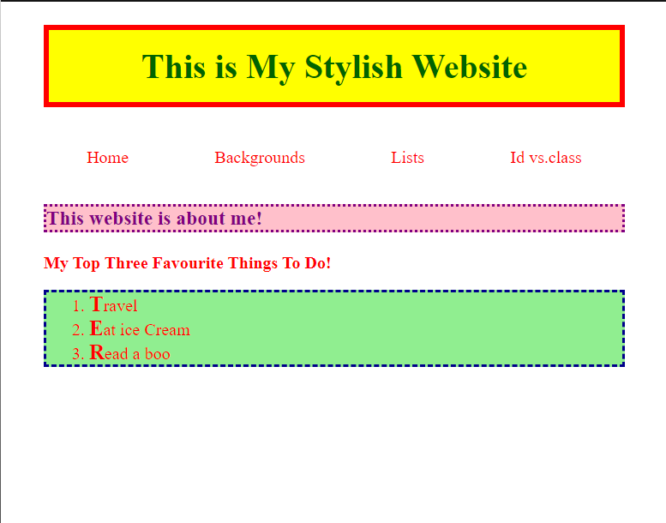

**a)**

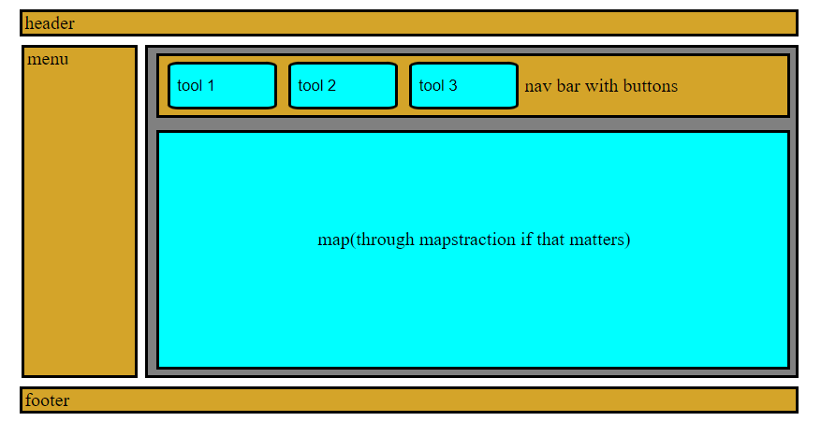**b)**

**c)**

**Ex No 9:** Input Output in JavaScript

**Aim:** To create an HTML page to explain input and output using a calculator with the use of various predefined functions and objects in JavaScript.

**Code:**

**a) Normal Calculator**

<!DOCTYPE html>

<html lang="en">

<head>

    <title>9a</title>

    <style>

        table{

            height: 300px;}

        #btn, #display{

            font-size: large;

            width: 100%;

            height: 100%;

            border-radius: 7px;}

    </style>

    <script>

        function cal() {

            document.getElementById('display').value = eval(document.getElementById('display').value);  }

    </script>

</head>

<body bgcolor="brown">

    <h1 align="center">Javascript Calculator</h1>

    <table align="center" class="title" id="calc">

        <tr>

            <td colspan="4"><input type="text" id="display" name="disp" onkeypress="return event.charCode>=48 && event.charCode<=57"></td>

        </tr>

        <tr>

            <td><input type="button" id="btn" value="7" onclick="document.getElementById('display').value += '7'"></td>

            <td><input type="button" id="btn" value="8" onclick="document.getElementById('display').value += '8'"></td>

            <td><input type="button" id="btn" value="9" onclick="document.getElementById('display').value += '9'"></td>

            <td><input type="button" id="btn" value="+" onclick="document.getElementById('display').value += '+'"></td>

        </tr><tr>

            <td><input type="button" id="btn" value="4" onclick="document.getElementById('display').value += '4'"></td>

            <td><input type="button" id="btn" value="5" onclick="document.getElementById('display').value += '5'"></td>

            <td><input type="button" id="btn" value="6" onclick="document.getElementById('display').value += '6'"></td>

            <td><input type="button" id="btn" value="-" onclick="document.getElementById('display').value += '-'"></td>

        </tr><tr>

            <td><input type="button" id="btn" value="1" onclick="document.getElementById('display').value += '1'"></td>

            <td><input type="button" id="btn" value="2" onclick="document.getElementById('display').value += '2'"></td>

            <td><input type="button" id="btn" value="3" onclick="document.getElementById('display').value += '3'"></td>

            <td><input type="button" id="btn" value="*" onclick="document.getElementById('display').value += '*'"></td>

        </tr><tr>

            <td><input type="button" id="btn" value="0" onclick="document.getElementById('display').value += '0'"></td>

            <td><input type="button" id="btn" value="%" onclick="document.getElementById('display').value += '%'"></td>

            <td><input type="button" id="btn" value="." onclick="document.getElementById('display').value += '.'"></td>

            <td><input type="button" id="btn" value="/" onclick="document.getElementById('display').value += '/'"></td></tr>

        <tr>

            <td colspan="2"><input type="button" id="btn" value="C" onclick="document.getElementById('display').value =''"></td>

            <td colspan="2"><input type="button" id="btn" value="=" onclick="cal()"></td>               </tr>

    </table>

</body>

</html>

**b) Scientific Calculator**

<!DOCTYPE html>

<html lang="en">

<head>

<title>9b</title>

<style>

.title {

margin-bottom: 10px;

padding: 5px 0;

font-size: 20px;

font-weight:bold;

text-align:center;

width: 447px;

color:black;}

#btn {

width: 55px;

height: 50px;

font-size: 15px;}

input[type="button"] {

background-color:gray;

color: black;

width:100%}

/* Set input textarea */

input[type="text"] {

background-color:lightgreen;

width: 370px;

height: 30px;

}

</style>

<script>

function backspace(calc) {

size = calc.display.value.length;

calc.display.value = calc.display.value.substring(0, size-1);}

function sum(calc){

if(calc.display.value.includes("!")) {

size = calc.display.value.length;

n = Number(calc.display.value.substring(0, size-1));

f = 1;

for(i = 2; i <= n; i++)

f = f*i;

calc.display.value = f;

}

else

calc.display.value=eval(calc.display.value);

}

</script>

</head>

<body bgcolor="blue">

<form name="calc" >

<h1 align="center">Simple Scientific Calculator</h1>

<table align="center" id="calc" border=1 style="background-color: black;" cellspacing="5px">

<tr>

<td colspan="6"> <input id="display" type="text" name="disp" onkeypress="return event.charCode>=48 && event.charCode<=57"> </td>

</tr>

<tr>

<td><input type="button" id="btn" value="1" onclick="calc.display.value+='1'"> </td>

<td><input type="button" id="btn" value="2" onclick="calc.display.value+='2'"> </td>

<td><input type="button" id="btn" value="3" onclick="calc.display.value+='3'"> </td>

<td><input style="background-color:pink" type="button" id="btn" value="C" onclick="calc.display.value=''"> </td>

<td><input style="background-color:pink" type="button" id="btn" value="<-" onclick="backspace(this.form)"> </td>

<td><input style="background-color:pink" type="button" id="btn" value="=" onclick="sum(this.form)"> </td>

</tr><tr>

<td><input type="button" id="btn" value="4" onclick="calc.display.value+='4'"> </td>

<td><input type="button" id="btn" value="5" onclick="calc.display.value+='5'"> </td>

<td><input type="button" id="btn" value="6" onclick="calc.display.value+='6'"> </td>

<td><input type="button" id="btn" value="-" onclick="calc.display.value+='-'"> </td>

<td><input type="button" id="btn" value="%" onclick="calc.display.value+='%'"> </td>

<td><input type="button" id="btn" value="cos" onclick="calc.display.value+='Math.cos('"></td>

</tr>

<tr>

<td><input type="button" id="btn" value="7" onclick="calc.display.value+='7'"> </td>

<td><input type="button" id="btn" value="8" onclick="calc.display.value+='8'"></td>

<td><input type="button" id="btn" value="9" onclick="calc.display.value+='9'"> </td>

<td><input type="button" id="btn" value="" onclick="calc.display.value+=''"> </td>

<td><input type="button" id="btn" value="!" onclick="calc.display.value+='!'"> </td>

<td><input type="button" id="btn" value="sin" onclick="calc.display.value+='Math.sin('"> </td>

</tr>

<tr>

<td><input type="button" id="btn" value="." onclick="calc.display.value+='.'"> </td>

<td><input type="button" id="btn" value="0" onclick="calc.display.value+='0'"> </td>

<td><input type="button" id="btn" value="," onclick="calc.display.value+=','"> </td>

<td><input type="button" id="btn" value="+" onclick="calc.display.value+='+'"> </td>

<td><input type="button" id="btn" value="/" onclick="calc.display.value+='/'"> </td>

<td><input type="button" id="btn" value="tan" onclick="calc.display.value+='Math.tan('"> </td>

</tr>

<tr>

<td><input type="button" id="btn" value="E" onclick="calc.display.value+='E'"> </td>

<td><input type="button" id="btn" value="pi" onclick="calc.display.value+='Math.PI'"> </td>

<td><input type="button" id="btn" value="x^y" onclick="calc.display.value+='Math.pow('"> </td>

<td><input type="button" id="btn" value="(" onclick="calc.display.value+='('"> </td>

<td><input type="button" id="btn" value=")" onclick="calc.display.value+=')'"> </td>

<td><input type="button" id="btn" value="log" onclick="calc.display.value+='Math.log('"</td>

</tr><tr>

<td><input type="button" id="btn" value="sqrt" onclick="calc.display.value+='Math.sqrt('"> </td>

<td><input type="button" id="btn" value="LN2" onclick="calc.display.value+='Math.LN2'"></td>

<td><input type="button" id="btn" value="LN10" onclick="calc.display.value+='Math.LN10'"> </td>

<td><input type="button" id="btn" value="log2E" onclick="calc.display.value+='Math.LOG2E'"></td>

<td><input type="button" id="btn" value="log10E" onclick="calc.display.value+='Math.log10'"> </td>

<td><input type="button" id="btn" value="exp" onclick="calc.display.value='Math.exp('"></td>

</tr>

</table>

</form>

</body>

</html>

**Output:**

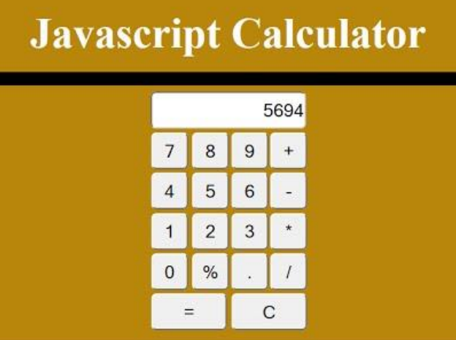**a)**

**b)**

**Ex No: 10 Window Object methods alert() , prompt() , confirm(), open(), close() , print(),**

**Aim:** To create an html page to explain the use of various predefined functions in window object in java script.

**Problem Statement:**

Create an html page named as “window.html” and within the script tag.

1. Use different window object.

**Code:**

<!DOCTYPE html>

<html>

    <head>

        <title>Exp-10</title>

    </head>

    <body>

        <div>

            <button onclick="alertGive()">Give Alert</button>

            <button onclick="funcPrompt()">Prompt</button>

            <button onclick="funcConfirm()">Confirm</button>

            <button onclick="openWindow()">Open Window</button>

            <button onclick="closeWindow()">Close Window</button>

            <button onclick="funcPrint()">Print</button>

        </div>

        <script>

            function alertGive(){

                window.alert("Alert!!!");

                console.log("Alerted")

            }

            function funcConfirm(){

                console.log("Response on Confirm: ",confirm("Do you want to confirm?"));

            }

            function funcPrompt(){

                var name = prompt("Enter your name:");

                console.log("Name via Prompt: ", name);

            }

            function openWindow(){

                window.open('https://geu.ac.in');

                console.log("New Window Opened");

            }

            function closeWindow(){

                window.close()

                console.log("Window CLosed so this wont be visible");

            }

            function funcPrint(){

                window.print();

                console.log("Print function called");

            }

        </script>

    </body>

</html>

**Output:**



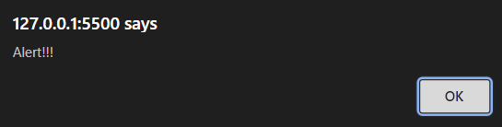

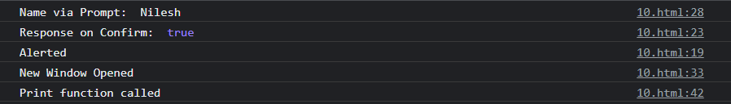

**Ex No: 11: Event Handling - Background Color Change**

**Aim**: To create an html page to change the background color for every click of a button using javascript.

**Problem Statement:**

1. Create a html page named as changebackground_color.html

2. Define a method named as random_color() which is to be called when you click on the body.

This method should generate random number, which is used to set the background color.

**Code:**

<!DOCTYPE html>

<html>

    <head><title>Exp-11</title></head>

    <body>

        <h1 onclick="change()"><center>Click me to change my color!</center></h1>

        <script>

            function change(){

                r = Math.floor(Math.random()*256);

                g= Math.floor(Math.random()*256);

                b = Math.floor(Math.random()*256);

                bgCol = "rgb(" + r + "," + g + "," + b+")";

                console.log(bgCol);

                document.body.style.background = bgCol;}

        </script>

    </body>

</html>

**Output:**

**Ex No: 12:** Event Handling - calendar for the month and year by combo box

**Aim**: To create an html page with 2 combo box populated with month & year, to display the calendar for the selected month & year from combo box using JavaScript.

**Code:**

<!DOCTYPE html>

<html>

<head>

<script>

var days=["sun","mon","tue","wed","thu","fri","sat"];

var mn= ["January","February","March","April","May","June","July","August","September","October","November","December"];

var last=[31,28,31,30,31,30,31,31,30,31,30,31];

var i=0,j,cnt=0,c;

var yr,k,mon;

function my(){

yr = document.getElementById("year").value

k = document.getElementById("month").value

if(yr%4==0)

last[1]=29;

k1 = k-1

var date2 = new Date(yr,k1,1)

// var date6 = new Date(yr,k1)

// console.log(date2);

var daz = date2.getDay()

//alert(days[daz])

document.write("<table width='50%' height='60%' border='9' bgcolor='cyan'>");

//document.write("<tr><td colspan='7'><center>"+ mn[k1]+" "+yr+"</center></td></tr>");

document.write("<tr><td colspan='7' align='center'>"+ mn[k1]+" "+yr+"</td></tr>");

document.write("<tr>");

for(i=0;i<=6;i++)

document.write("<td align='center' > <b>"+days[i]+"</b></td>");

document.write("</tr>");

document.write("<tr>");

cnt=0;

for(i=0;i<=daz-1;i++) {

document.write("<td></td>");

cnt=cnt+1;

}

for(j=1;j<=last[k1];j++) {

c=cnt%7;

if(c==0){

document.write("</tr><tr><td align='center'>"+j+"</td>");

cnt++;}

else{

document.write("<td align='center'>"+j+"</td>");

cnt++;

}}

document.write("</tr></table>");}

</script>

</head>

<body bgcolor="green">

<h1>Calender</h1>

<h2>Select Year</h1>

<form name="form1">

<select name="qual" id="year">

<option value=2014>2014</option>

<option value=2015>2015</option>

<option value=2016>2016</option>

<option value=2017>2017</option>

<option value=2018>2018</option>

<option value=2019>2019</option>

<option value=2020>2020</option>

<option value=2021>2021</option>

<option value=2022>2022</option>

<option value=2023>2023</option>

<option value=2024>2024</option>

</select>

<h2>Select Month</h1>

<select name="qual1" id="month">

<option value=1>JAN</option>

<option value=2 >2</option>

<option value=3>3</option>

<option value=4>4</option>

<option value=5>5</option>

<option value=6>6</option>

<option value=7>7</option>

<option value=8>8</option>

<option value=9 >9</option>

<option value=10>10</option>

<option value=11>11</option>

<option value=12>DEC</option>

</select>

<input type="button" value="ok" onclick=my()></input></form> </body>

</html>

**Output:**

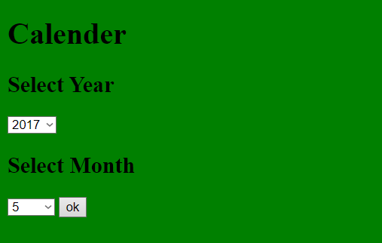

**Ex No: 13: Date Handling - calendar for the month and year by combo box Aim: To understand the date in java Script.**

**Problem Statements:**

a) Write a JavaScript program to display the current day and time in the following format.

Sample Output :

Today is : Friday.

Current time is : 4 PM : 50 : 22

b) Write a JavaScript program to get the current date.

Expected Output :

mm-dd-yyyy,

mm/dd/yyyy or dd-mm-yyyy, dd/mm/yyyy

c) Write a JavaScript function to get difference between two dates in days.

Test Data :

console.log(date_diff_indays('04/02/2014', '11/04/2014')); console.log(date_diff_indays('12/02/2014', '11/04/2014'));

Output :

216

-28

d) Write a JavaScript function to count the number of days passed since beginning of the year. Go to the editor

Test Data :

console.log(days_passed(new Date(2015, 0, 15)));

15

console.log(days_passed(new Date(2015, 11, 14)));

348

e) Write a JavaScript program to find 1st January is being a Sunday between year1 and year2.

f) Write a JavaScript program to calculate days left until next Christmas.

g) Write a JavaScript program to calculate days remains in your birthday.

**Code:**

<!DOCTYPE html>

<html>

<head>

<title>Exp-13</title>

</head>

<body>

<script>

var today = new Date();

//13a

console.log("13a -> ")

var daylist = ["Sunday","Monday","Tuesday","Wednesday ","Thursday","Friday","Saturday"];

var day = today.getDay();

var hour = today.getHours();

var minute = today.getMinutes();

var second = today.getSeconds();

var ampm = hour >= 12 ? 'PM' : 'AM';

hour = hour % 12;

hour = hour ? hour : 12;

var time = hour + ' ' + ampm + ' : ' + minute + ' : ' + second;

console.log('Today is : ' + daylist[day] + '.');

console.log('Current time is : ' + time);

//13b

console.log("13b -> ")

var dd = today.getDate();

var mm = today.getMonth()+1;

var yyyy = today.getFullYear();

if(dd<10)

dd='0'+dd;

if(mm<10)

mm='0'+mm;

date = dd+'/'+mm+'/'+yyyy;

console.log(date);

//13c

console.log("13c -> ")

var date_diff_indays = function(date1, date2) {

dt1 = new Date(date1);

dt2 = new Date(date2);

return (dt2-dt1)/(1000 * 60 * 60 * 24);

}

console.log(date_diff_indays('04/02/2014', '11/04/2014'));

console.log(date_diff_indays('12/02/2014', '11/04/2014'));

//13d

console.log("13d -> ")

function days_passed(dt) {

var current = new Date(dt.getTime());

var previous = new Date(dt.getFullYear(), 0, 1);

return Math.ceil((current - previous + 1) / (1000 * 60 * 60 * 24));

}

console.log(days_passed(new Date(2015, 0, 15)));

console.log(days_passed(new Date(2015, 11, 14)));

//13e

console.log("13e -> ")

for (var year = 2014; year <= 2050; year++)

{

var d = new Date(year, 0, 1);

if (d.getDay() === 0 )

console.log("1st January is being a Sunday "+year);

}

//13f

console.log("13f -> ")

let christmasYear = today.getFullYear();

if (today.getMonth() == 11 && today.getDate() > 25)

christmasYear = christmasYear + 1;

let christmasDate = new Date(christmasYear, 11, 25);

let days = Math.ceil((christmasDate.getTime() - today.getTime()) /(1000 * 60 * 60 * 24));

console.log(days);

//13g

console.log("13g -> ")

var myBirthday, today, bday, diff, daysleft;

today = new Date();

bday = new Date(today.getFullYear(),5,23);

if( today.getTime() > bday.getTime())

bday.setFullYear(bday.getFullYear()+1);

diff = bday.getTime()-today.getTime();

daysleft = Math.floor(diff/(1000*60*60*24));

console.log(daysleft);

</script>

</body>

</html>

**Output:**

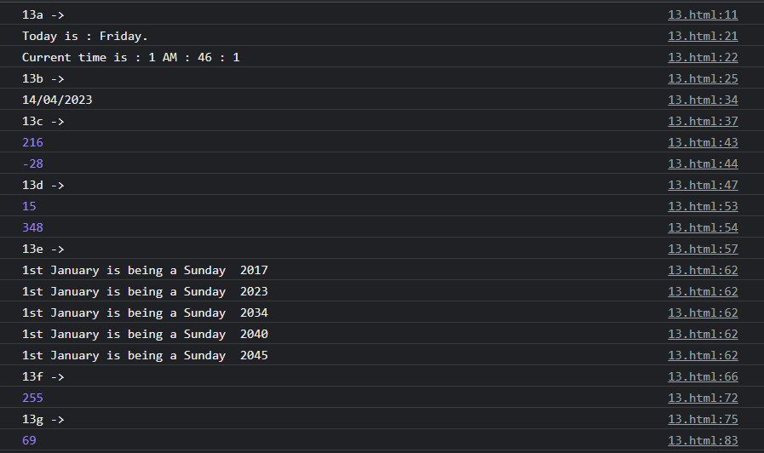

**Ex No: 14: Window object method setInterval, clearInterval**

**Aim**: To create an html page with three button START PAUSE and RESET for controlling stopwatch

**Problem Statement:**

Create a html file named as “stopwatch.html”

1. Add number div display HH MM SS.

2. When the button is clicked START start watch.

3. When the button is clicked PAUSE stop watch.

4. When the button is clicked RESET reset div values 00:00:00.

5. Add a save lap functioning button

**Code:**

<!DOCTYPE html>

<head><title>Exp-14</title>

<style>

body {

padding: 0;

margin: 0;

font-family: verdana;

}

.container {

display: flex;

flex-direction: column;

justify-content: center;

align-items: center;

width: 100%;

height: 100vh;

background-color: rgb(189, 188, 188);

}

#time {

font-size: 70px;

color: #158a56;

}

#buttons {

margin: 20px;

}

.btn {

align-items: center;

width: 100px;

padding: 10px 15px;

margin: 0 10px;

border-radius: 5%;

cursor: pointer;

font-size: 20px;

color: rgb(0, 0, 0);

font-weight: 500;

background-color: rgb(168, 165, 165);

border-color: rgb(184, 183, 183);

}

.added{

display: block;

padding: 0 10px;

font-size: 30px;

}

.butt{

display: flex;

flex-direction: column;

justify-content: center;

align-items: center;

}

.savelap .btn{

width: 350px;

}

</style>

</head>

<body>

<div class="container">

<div id="time">

<span class="digit" id="min">00</span>:<span class="digit" id="sec">00</span>:<span class="digit" id="count">00</span>

</div>

<div class="lapped" id="lap">

</div>

<div class="butt">

<div id="buttons">

<button class="btn" id="start" onclick="start()">START</button>

<button class="btn" id="stop" onclick="pause()">PAUSE</button>

<button class="btn" id="reset" onclick="reset()">RESET</button>

</div>

<div class="savelap">

<button class="btn" id="save" onclick="save()">Save Lap</button>

</div>

</div>

</div>

<script>

let minute = 00;

let second = 00;

let count = 00;

function start(){

timer = true;

stopWatch();

}

// Using setInterval

//function start(){

// timer = true;

// const myInterval = setInterval(stopWatch, 10);

//}

function pause(){

timer = false;}

function reset(){

timer = false;

minute = 0;

second = 0;

count = 0;

document.getElementById('min').innerHTML = "00";

document.getElementById('sec').innerHTML = "00";

document.getElementById('count').innerHTML = "00";

document.getElementById('lap').innerHTML = ""; };

function save(){

let minString = minute;

let secString = second;

let countString = count;

if (minute < 10) minString = "0" + minute;

if (second < 10) secString = "0" + second;

if (count < 10) countString = "0" + count;

let x = '<span class="added">' + minString + ':' + secString + ':' + countString + '</span>';

document.getElementById('lap').innerHTML += x;}

function stopWatch(){

if (timer)

{count++;

if (count == 100) {

second++;

count = 0;}

if (second == 60) {

minute++;

second = 0; }

let minString = minute;

let secString = second;

let countString = count;

if (minute < 10) minString = "0" + minString;

if (second < 10) secString = "0" + secString;

if (count < 10) countString = "0" + countString;

document.getElementById('min').innerHTML = minString;

document.getElementById('sec').innerHTML = secString;

document.getElementById('count').innerHTML = countString;

setTimeout(stopWatch, 10);

// Using setInterval

//if(!timer)

// clearInterval(myInterval);

}

}

</script>

</body>

</html>

**Output:**

